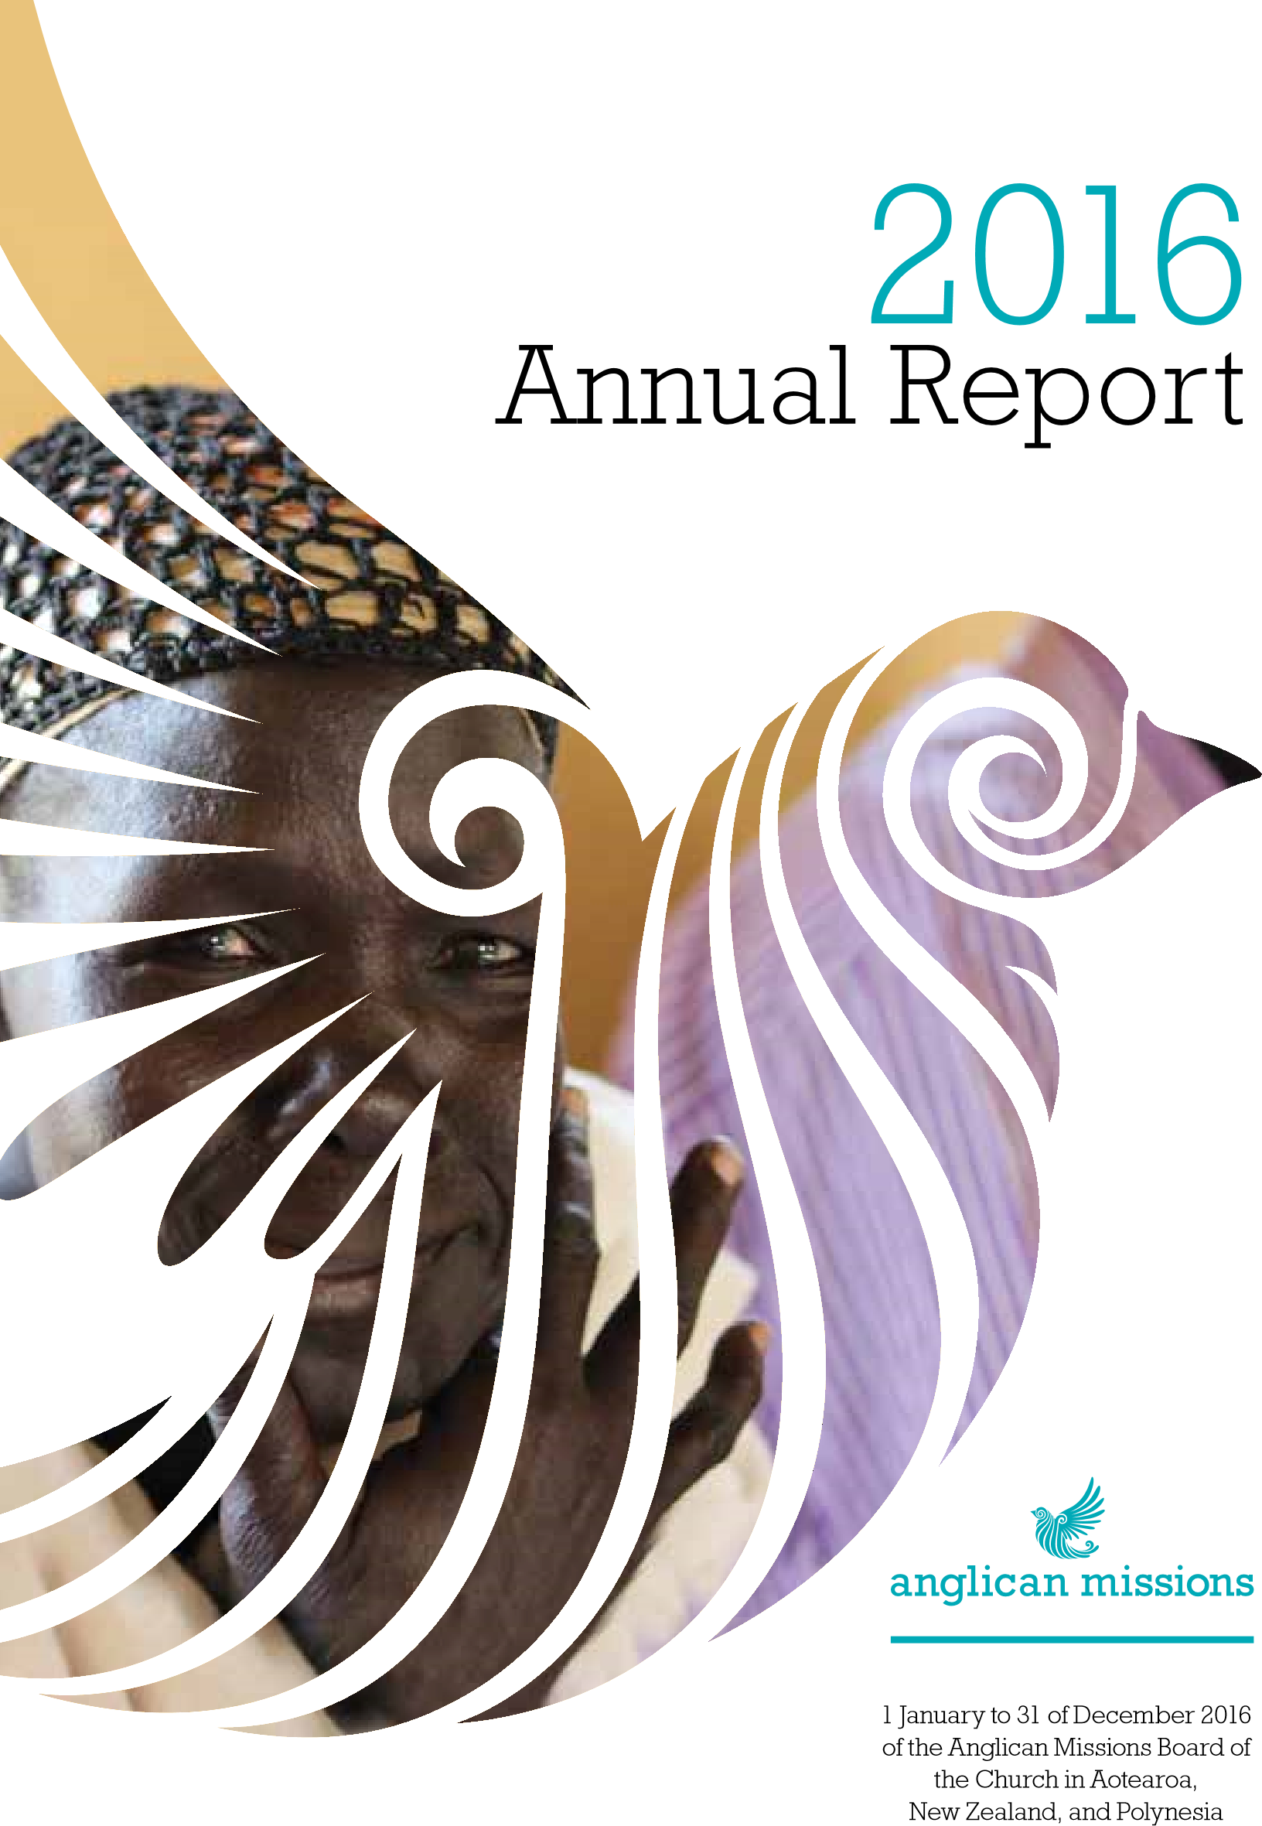
Annual Report for the year
The Anglican Missions Board of the Church in
Aotearoa, New Zealand, and Polynesia.
Mulgrave St / PO Box 12012,
32
Thorndon, Wellington 6144, New Zealand.
Tel: +64 4 473-5172 / Fax: +64 4 499-5553
office@angmissions.org.nz
www.angmissions.org.nz
www.facebook.com/AnglicanMissions
A Summary of the Board’s Financial
Statements will be published in May 2017,
on the Anglican Missions website www.
angmissions.org.nz. A full set of Audited
Accounts may be obtained, on approval,
from the Anglican Missions Office.
Cover photo – Gambella, Ethiopia
CONTENTS
Introduction ................................................................................3
Our Work ....................................................................................7
Your Gifts .................................................................................16
2016
Summary Financial Statements ........................................
22
Board and Staff ..........................................................................23
2

OUR MISSION
The Mission Statement of the Board declares that the Anglican Missions Board enables the Anglican Church in Aotearoa, New Zealand and Polynesia, in a spirit of partnership, to share in the global dimension of Christ’s Mission. It does this by:
Mobilising the Church to pray, give, go and support the global missions of our Church, and to tell mission stories.
Partnering for effective mission with Partner Churches worldwide,
Tikanga mission enterprises, and associated Anglican and ecumenical mission agencies.
Resourcing effective mission with financial and cultural integrity; resourcing partnerships, emergency response, especially in our region, poverty projects; and acting as an agency for our diverse church.

OUR VISION
A primary focus for Anglican Missions is the Anglican Consultative Council’s Statement of Mission now incorporated into the Constitution of this Church.
Anglican Missions promotes this focus and encourages the church to:
Evangelise: Proclaiming the good news of the Kingdom.
Nurture: Teaching, baptising and nurturing the Christian Faith.
Serve: Responding to human needs by loving service.
Transform: Transforming the unjust structures of society.
Preserve: Preserving the integrity of creation for future generations.
3

Archbishop Winston meets with Maniava villagers.
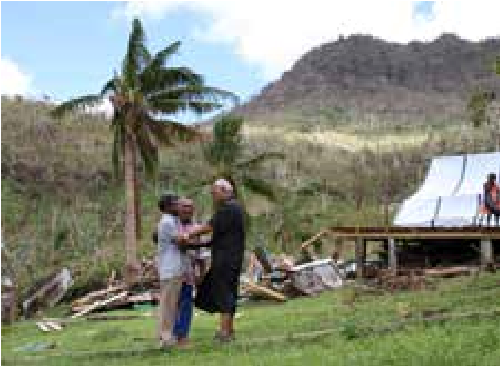
A BRIEF HISTORY
The Anglican Missions Board of the Church in Aotearoa, New Zealand and Polynesia (commonly known as Anglican Missions, AMB, or the Board) first established by the Church in 1920 and incorporated as a Charitable Trust in 1922. In 1998 the Board’s Canon was reviewed and updated to reflect the 3 Tikanga composition of the Church with AMB’s coordination of overseas mission being funded primarily through giving from parishes and rohe, with additional support coming from trusts, bequests and individuals. In 2008 the Board was registered as a charitable entity with the
Charities Commission in accordance with the Charities Act 2005*.
LOCAL SUPPORT NETWORKS
Currently Anglican Missions provides Mission Grants and Allocations in support of a wide range of mission activities including: the nurturing and provision of resources for new faith communities, aid and relief work, development projects, clergy support, assistance with church administration, theological training for church leaders, primary health care, education for children, the sending of Mission Partners, and special and emergency appeals. Anglican Missions coordinates multicultural mission in partnership with various overseas countries, India, S.E. Asia, Africa, the Middle East, Oceania, and The Pacific.
In presenting this Annual Report, The Anglican Missions Board (AMB) is grateful for the continuing partnership with Tikanga Missions Councils, Diocesan Missions Councils, parishes /rohe, various Church groups, trusts and individuals. Without their support, the sending of Mission Partners, the support of Church Partnerships and Mission Projects would not be possible.
Thank you!

*The Board does not have Donee Status, as specified under the 2007 Tax Act. (www.ird.govt.nz/charitable-organisations/ request-oseas-status/) and is therefore not able to give Tax Deductible receipts.
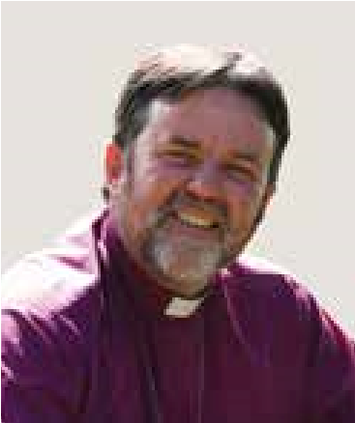
FROM THE BOARD CHAIR:

ARCHBISHOP PHILIP RICHARDSON
2016 has been a year of significant change for the Anglican Missions Board. The Board undertook a major independent review of its performance, governance and management structures; its stewardship of the funds that it received from the Church for Overseas Missions; and its relationships with
Archbishop Philip Richardson key partners, such as NZCMS who provide the specialist framework for selecting, sending and supporting mission
partners working around the world. The recommendations of the review were put before the General Synod Te Hinota Whanui in May 2016, and endorsed warmly by that body. Alongside these structural changes, the Board has refocused its mission and priorities under the exceptionally able leadership of Canon Robert Kereopa. The Board is developing an even higher profile, and deepening relationships closer to home in Oceania and East Asia. An example is our work in partnership with the Anglican Church of Papua New
Guinea, which is one of the poorest Provinces in the Anglican Communion. The Boards of NZCMS and AMB are working to ensure that priorities are strategic and aligned. In other words ensuring those we send as workers are deployed where there is a clear request from our overseas mission partners, and where the Boards are wanting to deliver the greatest long term benefit into the future and not simply reflective of historic relationships.
Collaboration with parallel organisations in other Provinces who are working with the same overseas mission partner is critical going forward to ensure there is not duplication of effort or resources.
Great care is being taken to ensure the proportion of the resources used for Board operations is as low as possible. It was gratifying that the independent review showed that the Board is performing very well compared to similar organisations in this regard and that the partnership with NZCMS, rather than duplication of effort and cost, has been an efficient and effective separation of focus and functions.
We can be very proud of the work of this organisation and its very committed staff. I am grateful to the deputy Chair Mr Steve Perris for being willing to take on a significant share of the governance leadership burden. His passion, experience, and skill are a perfect match for the leadership needs of the Board at this time.

Archbishop Philip Richardson
Chairman, Anglican Missions Board of the Church in Aotearoa, New Zealand, and Polynesia
5
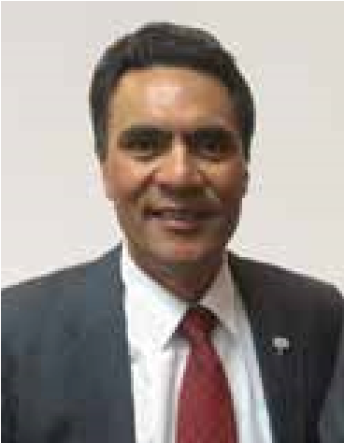
CEO KORERO:

BUILDING A RESILIENT PACIFIC
Building a resilient Pacific was a major focus for Anglican
Missions during 2016. After the devastation of Cyclone Winston, the rebuilding of 33 homes in Maniava village, Fiji was widely supported by our church and by partners overseas. Climate Justice and Natural disaster response will be a major focus for us moving forward as we encourage partnerships
Rev Canon Robert Kereopa and local empowerment in vulnerable areas particularly in the Oceania region.
For our work across the globe, 2016 has seen a lift in mission impact above expectations. We are thankful for the vision, fortitude and faithful witness of our many partners in mission, who seek to answer God's call to his mission. Through them missionaries have been sent to foreign lands; a new program to support vulnerable children started in Fiji; new churches and Sunday schools built; local peoples empowered to support vulnerable communities; emergency support and rebuilding supplies provided after another catastrophic cyclone in our region; healthcare resourced; health workers, pastors and youth ministers supported in difficult places; theological education resourced; land purchased for landless peoples; women, children and indigenous rights promoted; refugees assisted; practical help provided - the list goes on. Thank you Partners!
To our 3 Tikanga church, the dioceses, hui amorangi, parishes, rohe and church groups –we give thanks for your faithfulness and continued support for the overseas mission of our church. Without your commitment, prayer and gifts this mission we share would not be possible.
Finally, I want to thank our Chair, each Board and staff member, and each volunteer of AM for their hard work and contribution to the Board's vision, direction, and expression of mission. This has been a year of significant change with so much to be thankful for.
May God bless your faithful witness as we seek to grow in mission and partnership together.

Rev Canon Robert Kereopa
Chief Executive Officer,
Anglican Missions Board of the Church in Aotearoa, New Zealand, and Polynesia
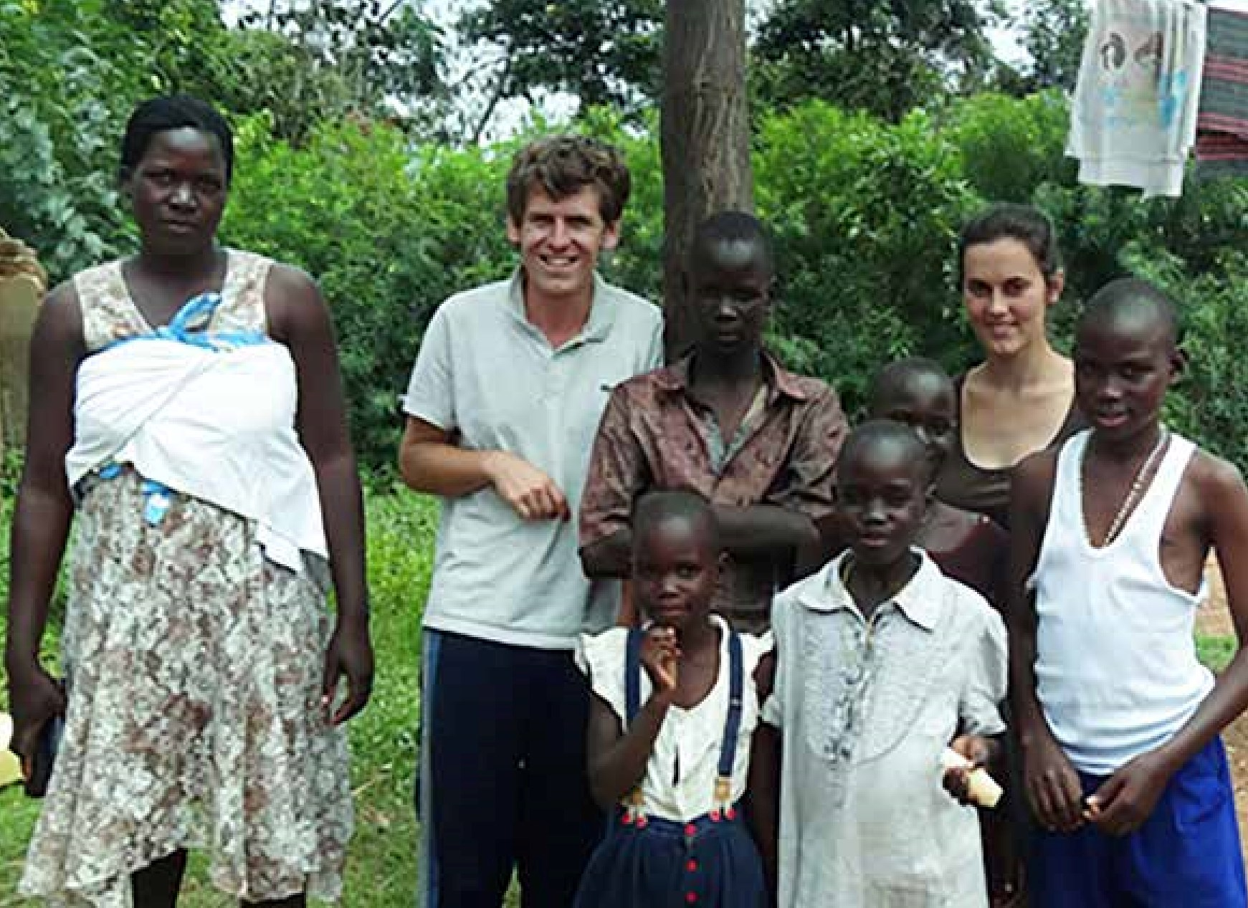

OUR WORK
MISSION WITH KEY PARTNERS
(
SCHEDULES, CANON IX, TITLE B
)
Significant grants went to the
work of:
•
NZCMS ($560,000)
- Anglican
Missions’ major support continues
to go to the New Zealand Church
Missionary Society (NZCMS) as it
has since the Board’s inception in
1922
. An Accord between Anglican
Missions and NZCMS forms the basis
of a partnership between the two
entities. The AMB support enabled
approximately 32 Mission Partners to
serve overseas in educational work,
community development, medical
care, evangelism/church planting/
enabling ministry and literacy work.
They are all involved in helping
to transform, in some way, the
individuals and communities overseas
for Christ. NZCMS currently has
partners working in Asia, Europe,
Africa, the Middle East, the Solomon
7
Mission Partners Nick & Tessa Laing in Uganda.

Islands and Papua New Guinea. Many have been working overseas for some time & you can read about them in our Projects Booklet and on the NZCMS website. One new Mission Partner for 2016 is Margaret who has been working in Papua New Guinea as Executive Assistant alongside Archbishop Clyde. Her work enables mission and ministry to develop and grow in PNG.
- The Diocese of Polynesia ($230,332) to support various projects including Evangelism, Education, Mission
(Clergy) Support, Health and Development Projects including the resettlement of Landless People, Anglicare, House of Sarah (providing counselling, refuge, and training
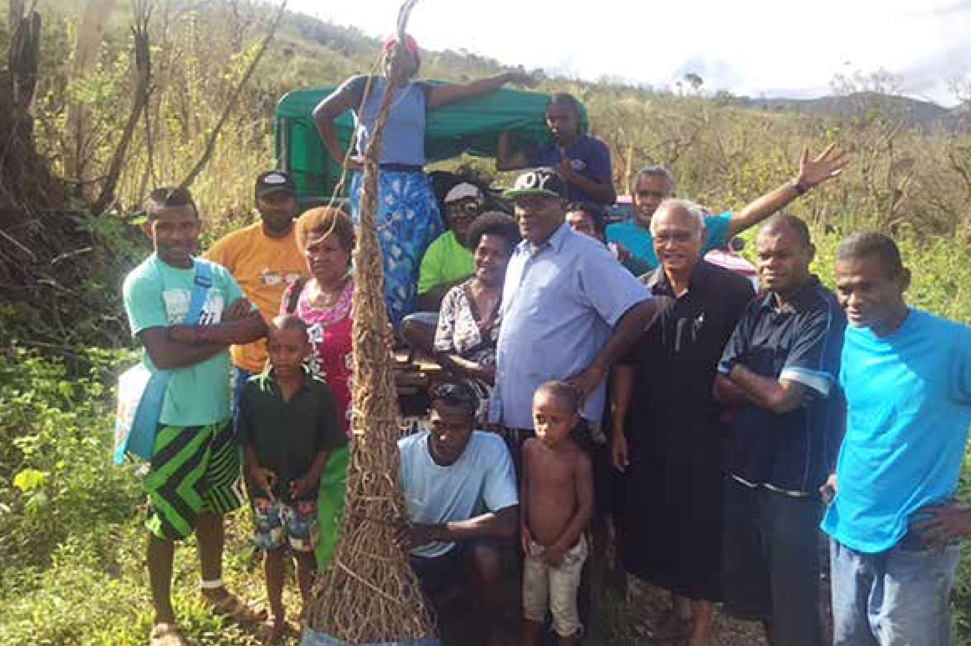
for women in Fiji and around the Pacific) and Mission Support for the clergy of the Diocese. The Drop-In Centre pilot project for young victims of commercial sexual exploitation was supported as one of the projects of the 2016 Lenten Appeal.
Archbishop Winston with villagers taking their crops to the market.
- Tikanga Maori Overseas Missions ($80,000) This annual grant of $80,000.00 to Tikanga Maori supports Te Pihopatanga o Aotearoa (The Maori Bishopric) in their work with specific partners to provide mission support overseas in different forms. A large part of this is the Australian Maori Missions outreach activities in Brisbane, Sydney, Melbourne and Perth.
A New Zealand secretariat also

supports the Anglican Indigenous Network. Te Pihopatanga is part of this network which comprises Anglican Indigenous minorities in various countries including Aotearoa NZ, Australian Aborigines,
Canada, Hawaii, USA and Torres Strait Islander.
- Anglican Church of Papua New Guinea ($99,000) A significant grant from the Henry and William Williams Memorial Trust continues to support the work of ACPNG, including support for Newton Theological College, Kerina Evangelists College and support for the Archbishop's office and administration.

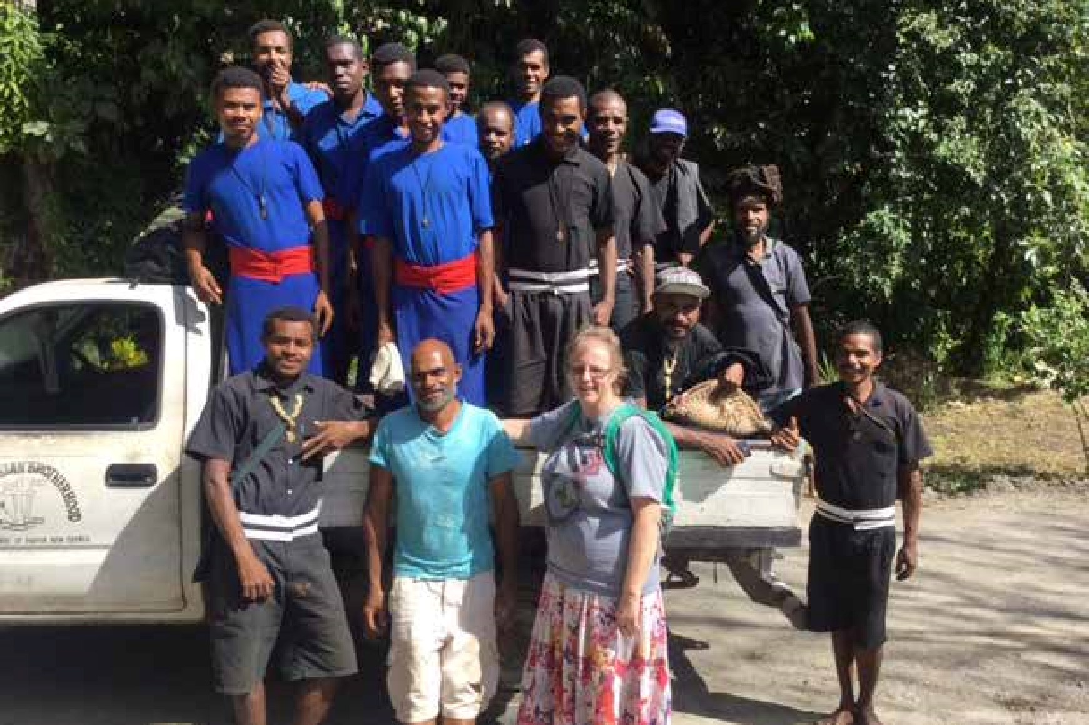
MISSION WITH OTHER CHURCH PARTNERS
Newton College, Poppondetta, PNG -Margaret (NZCMS Mission Partner) with the Christian Brothers.
- Tikanga Pakeha Overseas Missions ($10,618) supporting 3 parish Short Term Mission Teams in 2016. These parish groups went to Fiji, India, and Tonga. This grant is spent as required depending on applications received by the Overseas Missions Council of Tikanga Pakeha (OM-TP).
- The Church in Melanesia ($3,500) This grant (similarly to last year) supported the Christian Care Centre, clergy training, and the purchase of teaching and learning materials for clergy, as well as enabling a number of community projects including poultry farming by the Society of St Francis, a sewing project and vegetable farming by the Sisters of the Church. An additional project was the purchase of office uniforms for Provincial office and Mission staff.
- The Anglican Church of Tanzania ($18,000) This grant went towards the cost of holding a workshop for representatives of the 27 Dioceses to meet and formulate a Strategic Plan for the next 5 years; as well as the costs for the Archbishop to visit 5 Dioceses over the year.
- The Episcopal Church in Jerusalem and the Middle East ($32,866) These funds supported the building of on-site accommodation for
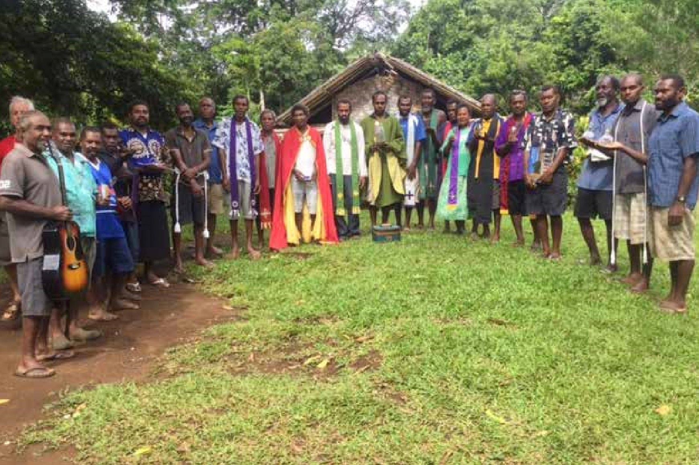
faculty at St Frumentius Theological College in Gambella, Ethiopia; and accommodation and ministry requirements for new Deacons in the Diocese of Iran.
Clergy at Pentecost, Vanuatu with vestments from Waikato Cathedral Apr2016.
- The Diocesan Boys Hostel in Pakistan ($11,000) supporting the education of the boys by providing water for the hostel, discipleship & leadership development, maintenance and repairs, educational costs and students’ breakfasts.
- Specified Donations ($158,095) These are donor donations received for mission work outside the usual operations of the Board, and transmitted overseas in accordance with the wishes
of the donors. These specified donations are recorded as income and expenditure once they are distributed as they represent significant extra giving by the Church. (The donations are processed with no administration charge levied).

MISSION IN ACTION

• St Christopher's Home Fiji
Tertiary Scholarship ($9,391) Funds have been invested in support of children from St Christopher's home in Fiji to support their tertiary education, and interest funds are disbursed each year.
- Fiji Cyclone Winston Appeal
($136,747) This major Emergency Appeal held in 2016 was in response to the devastation caused by Cyclone Winston in Fiji, and in particular in the village of Maniava. An excellent response to this Appeal ($136,747 received) led to some residual funds still being available to be paid as required towards rebuilding during 2017.
- Vanuatu Emergency ($20,321) An Appeal was launched in 2015 in aid of those affected by Cyclone Pam and these additional funds were received in 2016.
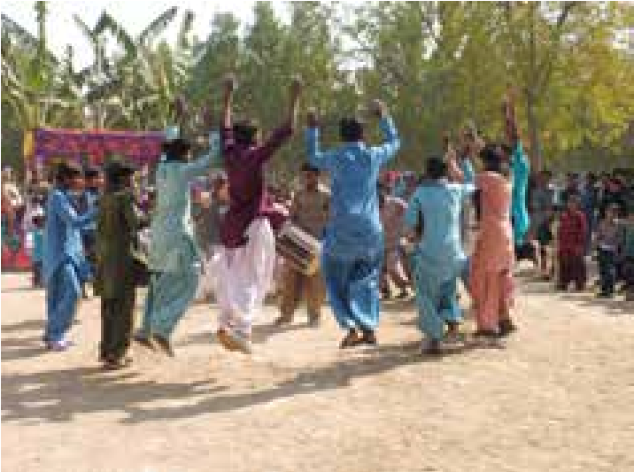
Hostel boys, Pakistan using song and dance to teach Christian truths.

MISSION ENGAGEMENT

($205,029)
Raising awareness, maintaining the profile of overseas mission, supporting the church through the provision of publications, websites and resources, holding mission focused events, and providing ongoing mission opportunities including arranging visitors from overseas and Mission Partner deputations in cooperation with NZCMS. This is a crucial investment in ensuring the church maintains its focus in overseas mission. During 2016 Anglican Missions employed a full time Church Support/Projects Officer and a Communications
Officer to help coordinate this work.

Church support

($72,562)
In 2016 the Church Support Officer/
Projects Officer (CSO) Rev. Mike Hawke maintained his presence throughout the Province, with a mixture of local and overseas visits. He visited many parishes, attended 3 Diocesan Synods and spoke at a number of schools, AAW meetings, men’s breakfasts and teas, mission events plus helped lead a pilgrimage to Jordan/Israel, Palestine and Turkey.
After six years working at Anglican
Missions Mike moved on at the end of
2016 to a new role as Dean of Nelson
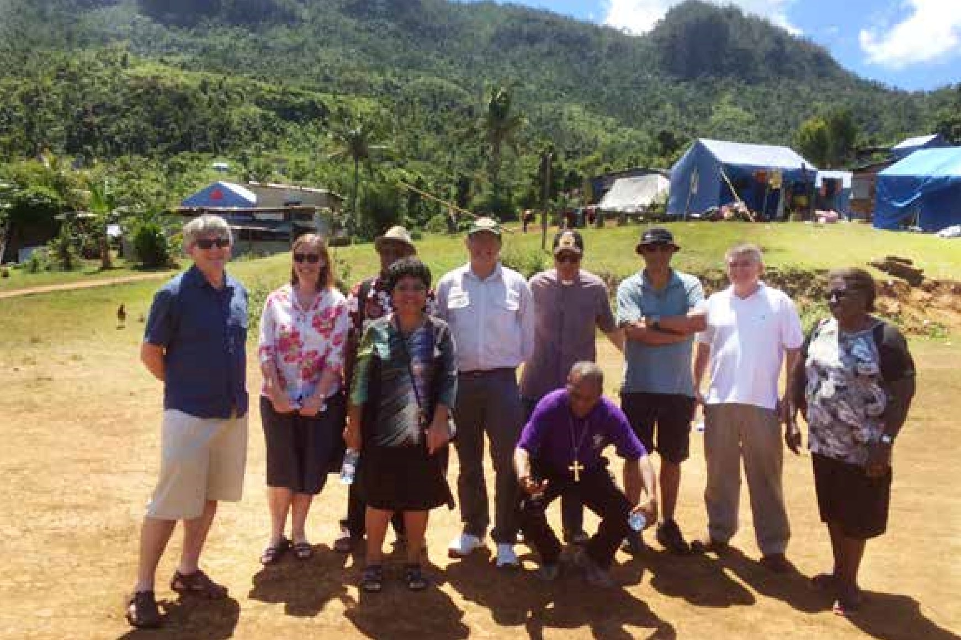
Cathedral. You can read more of Mike’s work in our December 2016 Mission Action magazine – either in hard copy from the office or through our website.
Anglican Alliance Pacific regional group at Maniava, Fiji Sept 2016.

Promotions

($98,632)
Publications and Physical resources:
Mission Action, Partners in Prayer, Wall Planner, Lenten and Database Appeals, EO and CSO Parish Visitations. Digital resources: Mission Action, Partners in Prayer, PowerPoint, Facebook, Website and electronic newsletters.
Anglican Missions sends out electronic newsletters approximately every 6 weeks to supporters, parishes and Mission Motivators about mission stories, news and resources. At the end of 2016 we had around 865 subscribers to our electronic news. Engagement with Anglican Missions on Facebook is growing. We endeavour to keep our website as the hub for all information regarding overseas mission with Anglican Missions.

Staff visits to overseas partners

($33,835)
Canon Robert Kereopa, CEO travelled to
- Honiara – April 2016 – with Archbishop Philip (Board Chair) for the Oceania
Regional Advisory Council of the
Anglican Alliance
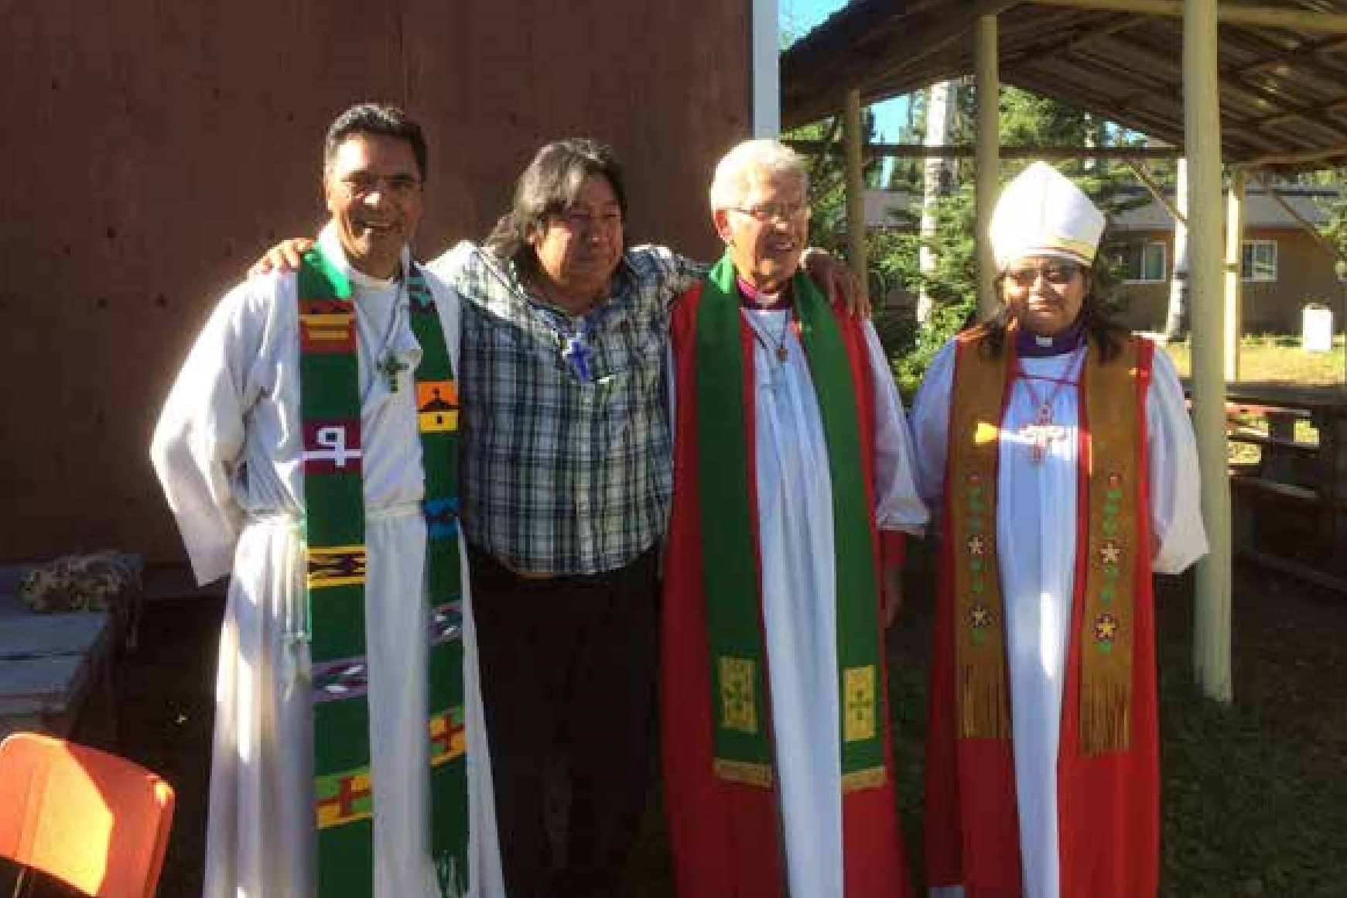
- Tanzania – June 2016 – see article in our December 2016 Mission Action magazine
Canon Robert Kereopa with Bishop Ngarahu, their translator Charlie Childforever and Bishop
Lydia, Canada.
- Canada – July/Aug 2016 – While on sabbatical including:
  - General Synod, Anglican Church of
Canada
  - USA Episcopal Relief & Development
Organisation of ECUSA
  - preaching & teaching at the Summer School of the Indigenous Spiritual
Ministry of Mishamikoweesh, the Anglican Church of Canada’s first indigenous Diocese.
  - Fiji – September 2016– with the
Anglican Alliance Pacific Regional Group, included a visit to Maniava village devastated by Cyclone Winston.
Revd Mike Hawke, Church Support/Projects
Officer travelled to Fiji, Papua New Guinea, Vanuatu and on pilgrimage to Jordan, Israel/ Palestine & Turkey.

Visitors to New Zealand
NZCMS Mission Partners in NZ on Leave &
Home Service
- Murray & Féy Cotter visiting mainly
Wellington, Canterbury and Auckland
Dioceses
- 5 Mission Partners from South Asia visiting mainly Waiapu, Dunedin, Auckland & Wellington Dioceses and Christchurch & Nelson Dioceses.
- 3 Mission Partners from Middle East visiting mainly Wellington, Nelson, Waiapu and Waikato Dioceses.

Companion Dioceses
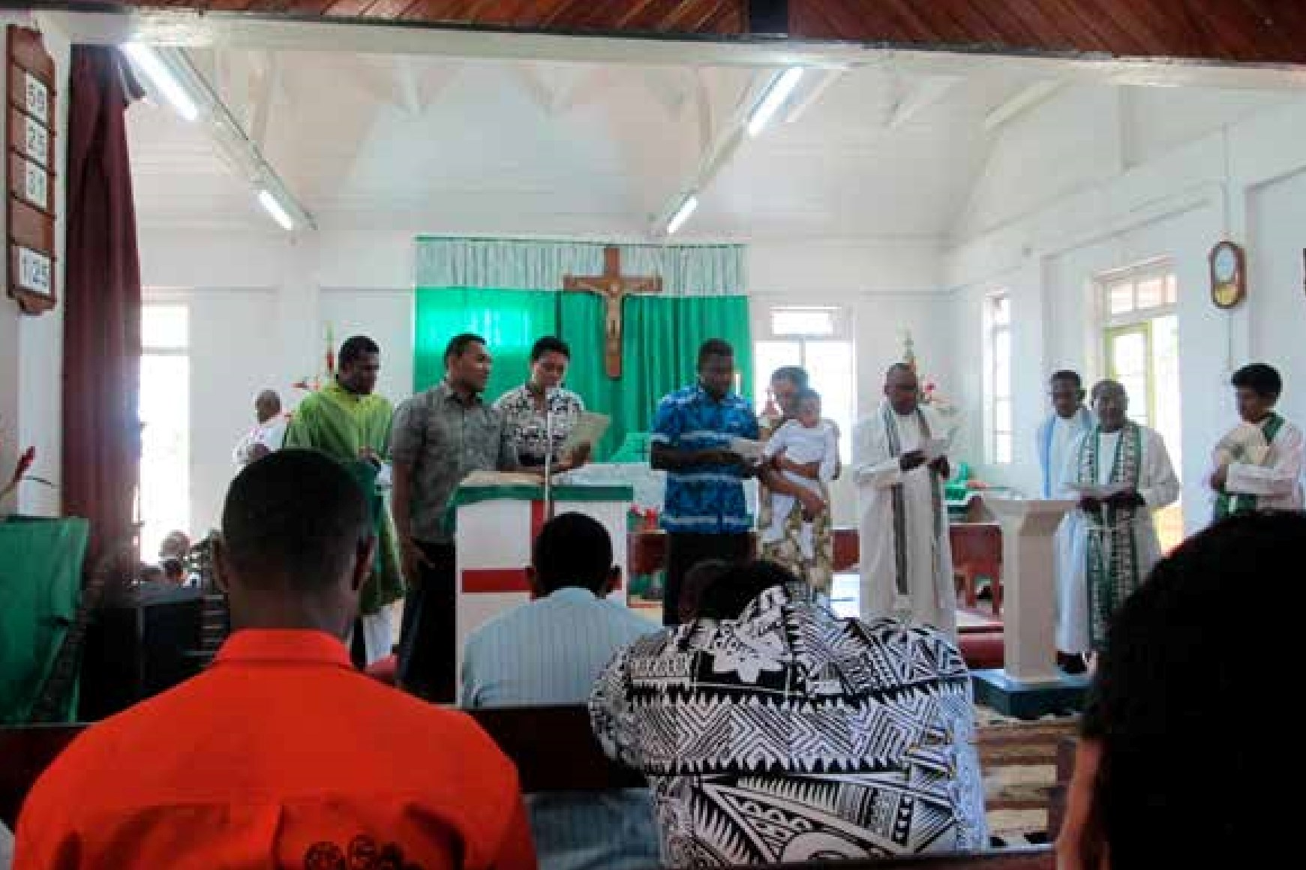
The Anglican Church of Aotearoa, New Zealand and Polynesia continues to forge relationships with Companion Dioceses overseas. The Companion Dioceses relationships are:
Church service, Fiji.
- Nelson: Singapore and Malaita
(Solomon Islands)
- Waikato and Taranaki: – Kuching in Malaysia
- Christchurch – Matana in Burundi
- Wellington – Diocese of Polynesia
- Dunedin – Edinburgh and Eastern Zambia
- Auckland – The Auckland Diocese doesn't have any Companion Diocese relationships, however we have an active relationship with the Archbishop and Province of Melanesia, in conjunction
with the Melanesian Mission Trust Board
- Waiapu – Companion relationship with The Province of PNG
- Te Tai Tokerau – Kondoa Diocese in Tanzania
- Te Pihopatanga o Aotearoa – Hawaii, Southern Ohio, Sydney, Melbourne, Brisbane, Perth, First Nations Peoples of Canada, Australian Aborigines and Torres Straits Islanders, and the Native Episcopal Church in USA America.

ORGANISATION COSTS
($414,597)

(1)Administration

$256,361
It was noted by independent reviewers that Anglican Missions (AM) is operating well within best practise in relation to Administration costs. Essential administration services ensure Anglican Missions maintains its high standard of funds accountability and transparency.

(2) Anglican House Premises use and ownership

$122,753
The Board regularly reviews the costs and benefits of its 50% ownership of Anglican House, acknowledging that while, as a former Bishop’s residence, it is a Taonga of the church, continued ownership and occupancy must also be seen to be commercially viable. We continue to be thankful for the provision of an office in such a strategic place in Wellington. The access is easy for all public transport, and we are close to the Diocesan Office and share good fellowship and relationship with the Anglican Church Pension Board whose office is in the building. The Board Room at Anglican House is used regularly, both by the Pension Board, Anglican Missions and Anglican Missions partners e.g. OM-TP (Overseas Mission of Tikanga Pakeha).

(3) Governance and Audit

$35,483
Ensuring that Anglican Missions continues to operate with best practise governance and decision making in accordance with the Board’s Canon and the aspirations of the three Tikanga. During 2015, the AM Board undertook an independent governance review that added significantly to the Board’s costs. As this was completed last year, this year’s costs are considerably less.

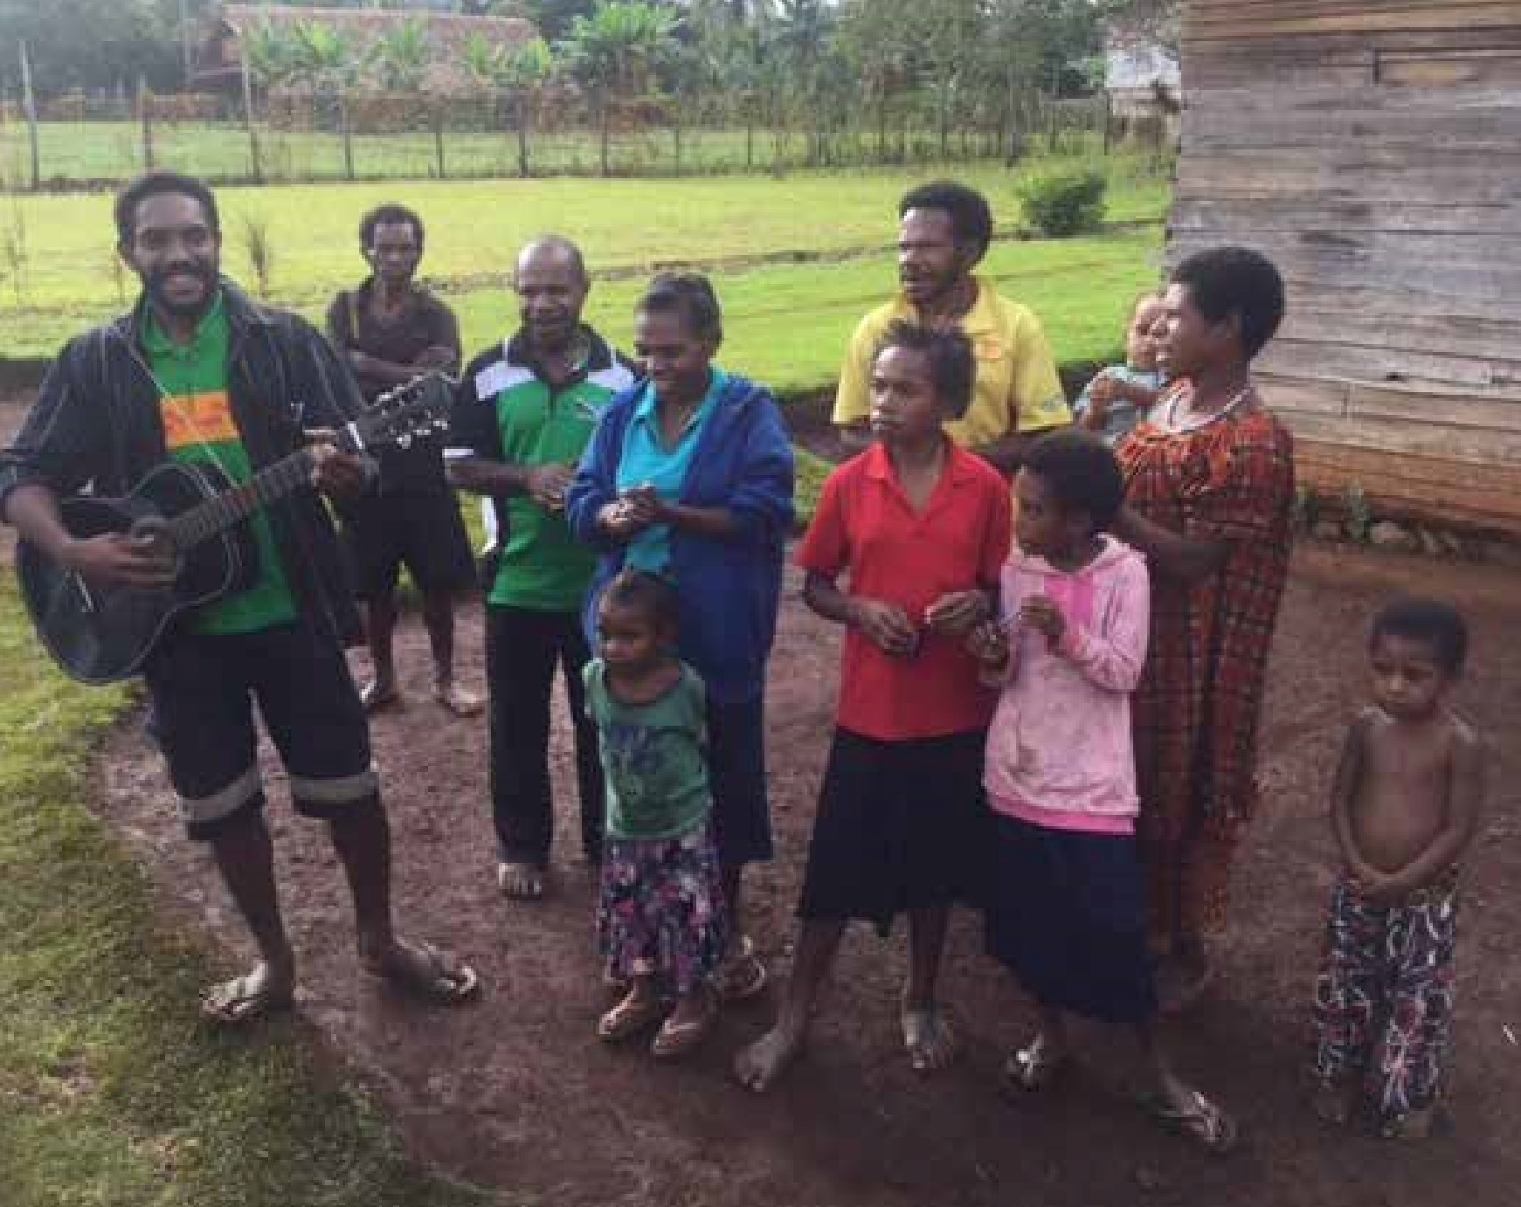

16
2016
TIKANGA GIVING
$1,247,979
Anglican Missions funds the
overseas mission of the Church
primarily through pledged giving
from individual parishes/rohe in
consultation with Diocesan and
Tikanga Mission Councils. Tikanga
contributions for each Diocese is listed
on page 17. The Board is very grateful
for the continued strong commitment
to overseas mission received from the
church year after year. Tikanga Giving
is the essential fuel to support the
mission we all share.
YOUR GIFTS
Guitar and strings donated by supporters of AMB.
16

SPECIAL APPEALS THANK YOU Fundraising
2016 SUMMARY OF TIKANGA GIVING

Income | 2016 ($) | 2015 ($)
Auckland | 215,206 | 218,202
Waikato & Taranaki | 180,223 | 185,458
Waiapu | 192,774 | 195,041
Wellington | 222,587 | 235,010
Nelson | 120,780 | 130,662
Christchurch | 223,326 | 220,700
Dunedin | 53,958 | 56,752
Polynesia | 12,185 | 7,910
Te Pihopatanga | 26,940 | 21,372
Total Tikanga Contributions 1,247,979 1,271,108
AM wishes to acknowledge the The Office continues to grow a database generosity of donors, in particular the of individuals interested in supporting Henry & William Williams Memorial the work of Anglican Missions directly. Trust ($160,440 of which $65,240 specifically supports Papua New Guinea) and the Association of Anglican Women ($20,700) who continue their longstanding support of Overseas Mission.

LENTEN APPEAL
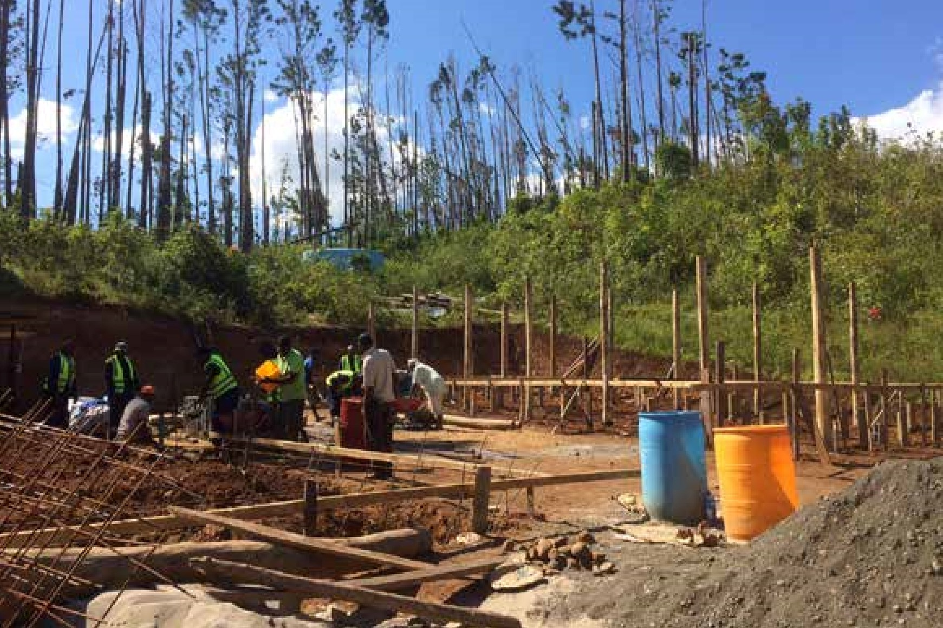
The 2016 Lenten Appeal included three projects – one from the Episcopal Diocese of Jerusalem, one from the Diocese of Egypt with North Africa and the Horn of Africa, and one from the Diocese of Polynesia in Fiji. The Appeal raised NZ$52,285. The projects were a Drop-In Centre in Suva for young victims of commercial sexual exploitation (CSEC), faculty accommodation for St. Frumentius’ Theological College, Ethiopia, and Deacon ministry support in Iran.
Children's hostel is first priority for solid rebuild at Maniava Sept2016.
18

Suva, Fiji
The Lenten appeal provided NZ$20,000 to support a pilot project to establish a Drop-In Centre for the young victims of Commercial Sexual Exploitation of Children (CSEC). The Drop-In Centre will offer a safe refuge for these children to begin the process of healing and restoration.
The Diocese of Polynesia will partner with Homes of Hope and other organisations who will provide additional services. There is no other existing residential care home that meets the vulnerable and high risk situation that these children are entangled in, hence the dire need for a safe space for them to be helped.

Gambella, Ethiopia
Funds (NZ$15,049) sent for Gambella from the 2016 Appeal are being used toward the building of apartments for faculty at St. Frumentius’ Theological College. The Church in Ethiopia is rapidly growing with over eighty churches. There are only sixteen clergy serving these congregations and St. Frumentius’ Theological College fulfils a critical role to train new and existing clergy. This theological education is highly valuable and it will enable the clergy in Ethiopia to teach, preach and to do God’s work.

Iran
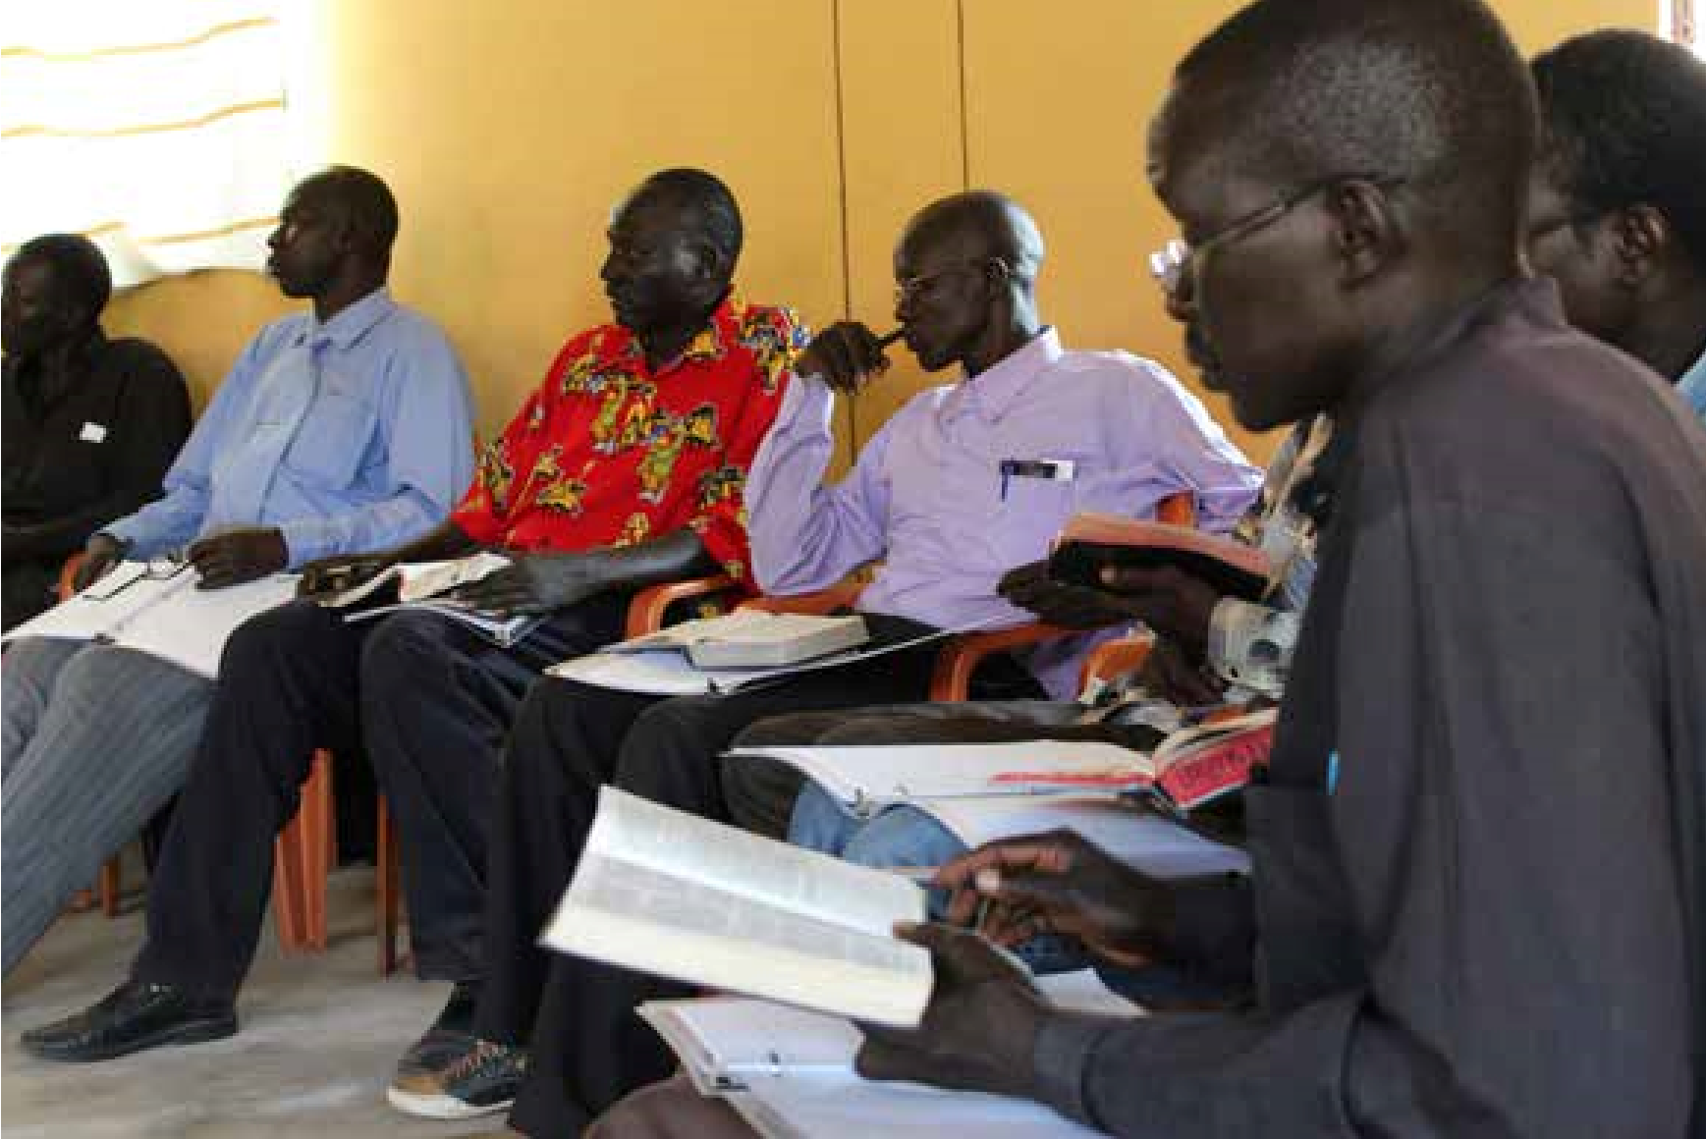
Funds (NZ$12,817) raised for Iran went toward accommodation and ministry requirements for Deacons serving in parishes in Tehran, Isfahan and Shiraz. Christians have been in this area since the very earliest Church ministry and the indigenous churches continue as minorities. With restrictions on the church in this area members need much prayer and support. Within the framework of permissions granted by the Islamic Republic of Iran, the Diocese has learnt to exist and serve the Lord with four places to operate from. Three new Deacons had recently been ordained when the Appeal was advertised and the funds raised were used toward their ongoing ministry requirements.
Gambella clergy.
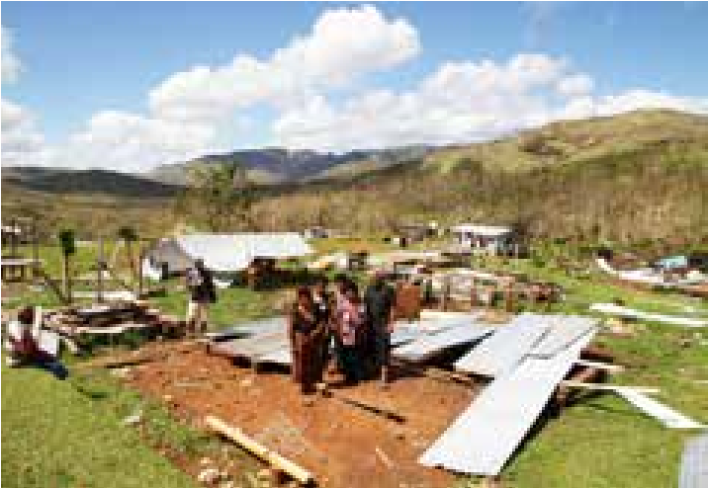
Most of the 32 houses at Maniava were lost in Cyclone Winston.

EMERGENCY APPEAL
On February 7th, 2016, Cyclone Winston devastated Fiji and was the strongest tropical cyclone to ever make landfall in Fiji and the South Pacific Basin. Anglican Missions immediately launched an emergency appeal to support Fiji and the Diocese of Polynesia raising NZ$136,747.
The devastation caused by Cyclone Winston in the village of Maniava was severe. Forty-four lives were lost and villages and communities were destroyed. It was decided with the Diocese of Polynesia that funds raised from the emergency will be used to rebuild Maniava. Maniava is a Koro (village) situated in Ra, on the eastern side of the main island of Fiji. One hundred and thirty eight people in Maniava lost their homes.
The main income in Maniava used to come from the land. The people planted yagona (kava) together with food crops to sell. With little support from the outside, Maniava had been built on the noble foundation of working together
20
and endeavouring to be self- supporting. Most of their crops, however, were destroyed in the Cyclone and only four houses were left standing.
Archbishop Winston Halapua visited Maniava along with Rev Mike Hawke shortly after the Cyclone and witnessed the devastation first hand. While damage was severe, hope among the people remained high as Mike and the Archbishop spoke and prayed with the villagers.
The rebuild in Maniava has started and is on-going. Updates from Maniava will continue to come through to the Anglican Missions office as progress continues throughout 2017.

SPRING APPEAL
In September 2016 Anglican Missions launched a Spring Appeal supporting three projects. We partnered with the Diocese of Hyderabad in Pakistan and with NZCMS and were able to support the following:
- Diocesan Boys Hostel, Mirpurkhas, Pakistan: The boys living in this hostel have access to valuable high school and college opportunities through which they are able to gain maturity, knowledge and life skills in order to go on and make a difference in the lives of their family, church and community. Much of the Christian leadership in the surrounding area including both church and local organisations
is from past hostel students. NZ$11,000 was provided for this project going towards: water for the hostel, discipleship and leadership development, maintenance and repairs, educational costs, and students’ breakfasts.
- NZCMS Mission Partners in the Middle East working with refugees and in Community Development: Supports a NZCMS Mission Partner who has been working alongside Syrian refugees in the Middle East since the beginning of the refugee crisis. Funds will also support two NZCMS Mission Partners who have been in the Middle East for many years, developing a wide range of ministries that have enabled them to connect with a variety of people groups. Funds raised totalled NZ$7,887.
- Nick and Tessa Laing, NZCMS
Mission Partners, Uganda: Nick and Tessa have been working in medical support and community development in Uganda since 2013. Last year Dr Nick took on a new role coordinating eight remote Anglican health centres that serve many people. The centres have been an important part of fighting a massive malaria epidemic and two new Centres were established last year. Tessa's particular focus is finding ways to connect the church with the community. Funds raised totalled NZ$8,021.
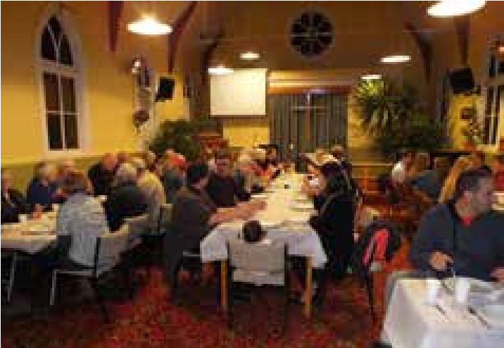
Kaponga Parish fundraising evening for Maniava rebuild.

BEQUESTS AND LEGACIES
Since the inception of the Board, many individuals have bequeathed sums of money to the Board for the purpose of supporting the global mission of the Church. Bequests and Legacies have become an important source of Mission Funds for the Board, contributing significantly to the Board’s “Mission Taonga”. Bequests of $25,000 were received in 2016.

STAMP SALES
Despite increasing use of email and not as many letters being sent, we are still raising useful funds for missions from the sale of used stamps collected and forwarded to us by many parishes and individuals. During 2016 we raised $6,740. We continue to be very appreciative of the volunteers who process the stamps and make them suitable for sale, and for those who organise the selling.

22
FINANCE SUMMARY

These figures are from our audited annual accounts for the year ending 31 December 2016

Mission – with Key Partners
$969,332
Diocese of Polynesia

230,332
Te Pihopatanga o Aotearoa (Tikanga Maori)
80
,000
NZCMS (NZ Church Missionary Society)
560,000

The Anglican Church of Papua New Guinea
99
,000

Mission – with The Church
$234,079
The Anglican Church of Melanesia
3
,500
The Episcopal Church in Jerusalem & Middle East
32
,866
The Church of Pakistan
11
,000
The Anglican Church of Tanzania
18
,000
Overseas Mission Tikanga Pakeha
10
,618
Specified donations passed on
158,095

Mission – In Action
$198,959
St Christopher's Home Fiji Tertiary Scholarship
9
,391
Fiji Cyclone Winston Appeal
136,747

Vanuatu Emergency
,321
20
AM Team - Project Support

,500
32
Mission – Engagement
$205,029
AM Team - Church Support
,562
72
Promotion and communications
,632
98
Mission Partner costs, Visits etc
,835
33

Total Mission Spending
$1,607,399

Organisation Costs
$414,597

Staffing
213,258
Technology & Equipment
,211
27
,440
3
Insurance
Stationery, Copier & Postage
9
,190
Other
3,261
Governance & Audit
35
,483
Premises use & Ownership

122,753

Total Spending
$2,021,996
Mission Funding (how we paid for it)
From our people
473,223
From our churches (Tikanga giving)
1,247,979
From Investments
45,652
From Partners
160,440
From Premises
117,082
From sales, stamps, etc.
21,871

2,066,247
22

BOARD AND STAFF
2016

Board of Trustees
From Sept 2016
Co-Presiding Bishop
Archbishop Winston Halapua
Archbishop Winston Halapua
Tikanga Maori

Bishop Ngarahu Katene
Bishop Ngarahu Katene

Rev Jacynthia Murphy

Mr Charles Hemana
Mr Charles Hemana
Tikanga Pakeha

Archbishop Philip Richardson
Archbishop Philip Richardson
(

Chair)
)
(
Chair

Mrs Mary Estcourt
Mr Steve Perris

Rev Dawn Daunauda
Tikanga Pasifika

Rev Amy Chambers
Rev Amy Chambers

Mr Joe Sanegar (sick leave)
Ven Henry Bull

Mr Sakiusa Tubuna
NZCMS

Rev Steve Maina
Rev Steve Maina

General Synod

Rev Michael Hughes
Rev Michael Hughes
Consultants

Rev Dawn Daunauda

Rev Jacynthia Murphy
ANGLICAN MISSIONS STAFF
Chief Executive Officer
Rev Canon Robert Kereopa
Church Support/Projects Officer
Rev Michael Hawke
Executive Assistant
Ms Metua Takairangi
Accounts Officer
Mr Sudesh Wasoori
Database
Ms Linda Dear
Communications
Ms Linda Dear and Miss Chelsea Kereopa
Accountant
Mr John Tapiata
Auditors

Grant Thornton
23
